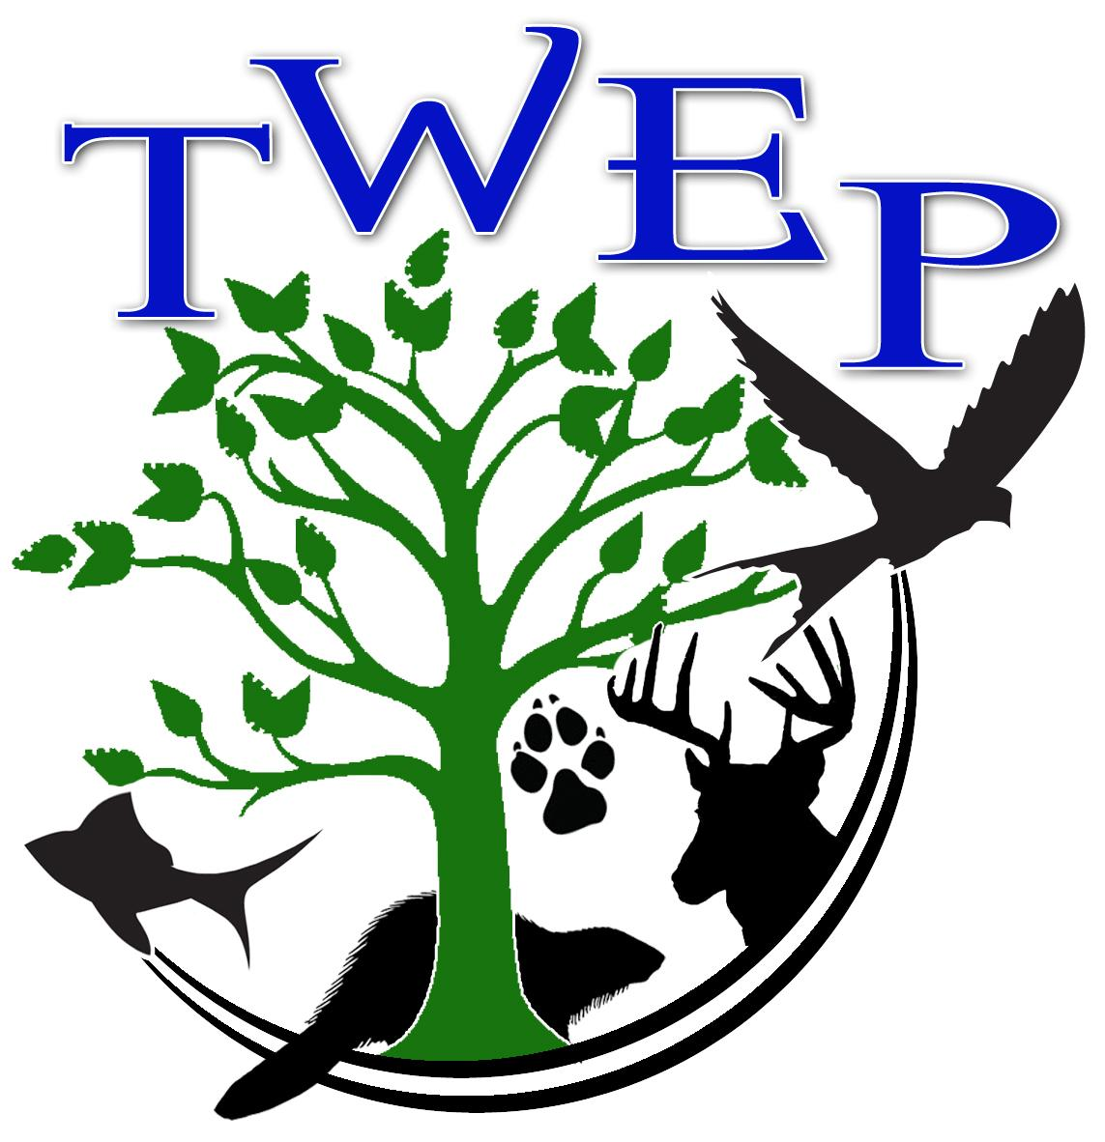 Fall 20121 After School Seminar “Biomechanics”

Class runs September 7 to October 28, Tuesdays and Thursdays from 3:45 - 5:00.
The $15.00 fee is due at the first class. Maximum number of students is 8 (eight), so you must pre-register.

Student name: __________________________

Grade _________________ School _______________________________

Student’s address: _________________________________
_________________________________

Parent’s Name: ___________________________________

Phone Number: ___________________________________

Email: __________________________________________

Emergency Contact: _________________ Phone: _______________________

Permission is hereby given for ____________________________ to participate in TWEP’s Seminar session. I certify that my child has no physical limitations that would impact his/her participation in this activity. I understand that my child will be walking to the Charles Brightbill Environmental Center from his/her school. (This applies to JBHS and JBMS students.) In the event of an injury, I understand that I am responsible for providing my own insurance for medical care. I also agree to not hold any of the staff or Board members of TWEP liable in the event of an injury.

Parent Signature: ___________________________ Date: ______________________

Return this form to TWEP, PO Box 97, Mercersburg, PA 17236
or email completed form to twepmail@gmail.com

