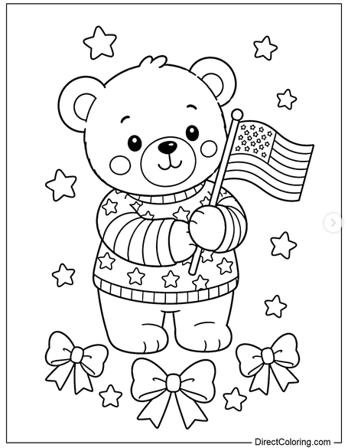
We Salute Our Veterans!

FIRST NAME_______________________
AGE_______________________________
PHONE____________________________
COLORING CONTEST

